Visualization Tool for Electric Vehicle Charge and Range Analysis

# Introduction

Electric Vehicles (EVs) have emerged as a transformative force in the global transportation sector. With significant advances in battery technology, sensor integration, and data-driven analytics, EVs are now more efficient, reliable, and widely adopted than ever before.  
  
While much of this progress has been hardware-driven, the real catalyst for innovation lies in data analytics — enabling insights into charging behavior, performance trends, infrastructure gaps, and user needs. This project aims to leverage data from multiple sources to build a comprehensive visualization tool that analyzes the range, charging infrastructure, and global trends of EVs.

**Electric Vehicle Charge and Range Analysis**

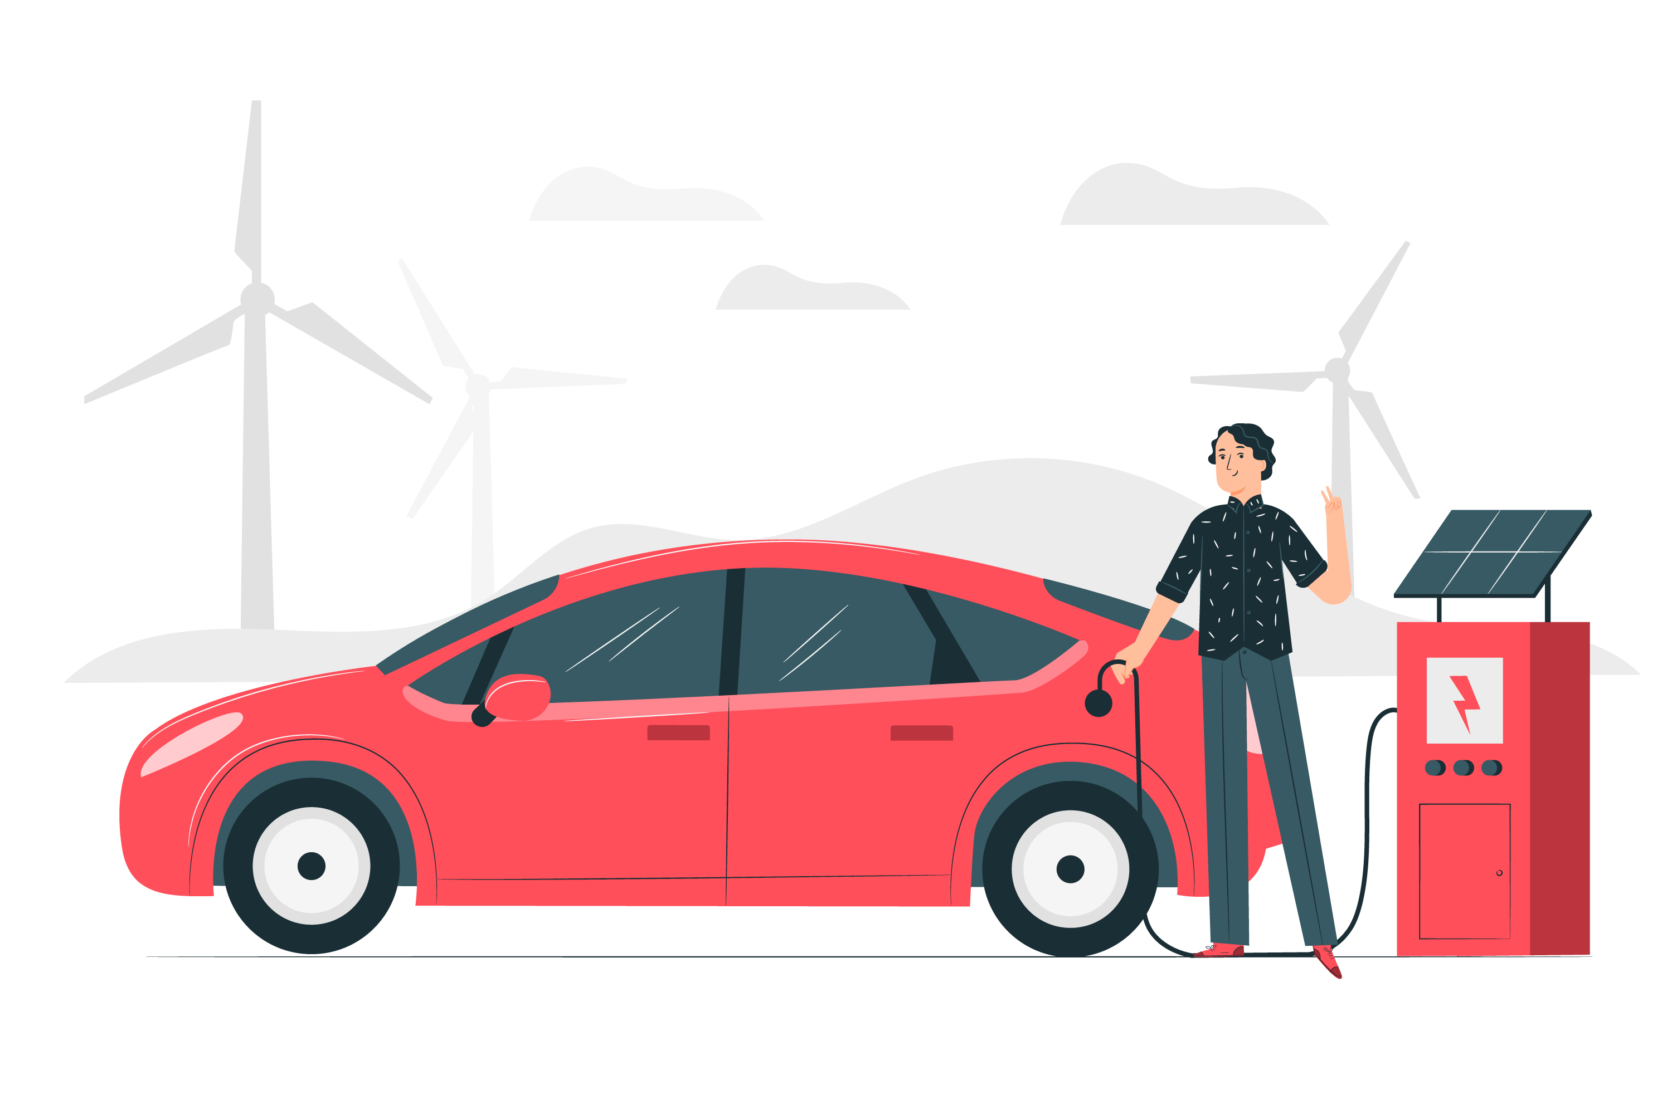

# Problem Statement

To understand the growing Electric Vehicle landscape, we need to analyze and visualize data from multiple sources — including Indian and global EV markets. The goal is to:  
- Combine data from 4 different datasets related to EV models, charging stations, battery performance, and market trends.  
- Create a dashboard and a storyboard that effectively communicate the insights through visuals.  
- Publish the visuals online and integrate them into a user-friendly web application.

# Project Flow

## 1. Data Collection

Sourced 4 datasets from public and industry sources, covering:

1. EV specifications (range, battery, price)
2. Charging station infrastructure (locations, availability)
3. Global and Indian EV sales data
4. Battery performance across environments

## 2. Database / Spreadsheet Connection

Structured the raw datasets into Google Sheets / Excel files. Ensured uniform formatting, naming, and consistent data types.

## 3. Data Import & Preprocessing

Imported datasets into Tableau Desktop by connecting directly to the structured spreadsheet. Performed data cleaning and transformation, including handling missing values, formatting fields, and creating calculated fields.

## 4. Data Analysis and Visualization

Developed insights based on key business questions and created multiple visualizations: Bar charts, Line charts, Pie charts, Geo-maps, Heatmaps, etc.

## 5. Dashboard Development

Designed an interactive dashboard in Tableau including overview KPIs, model comparisons, infrastructure visuals, and sales trends.

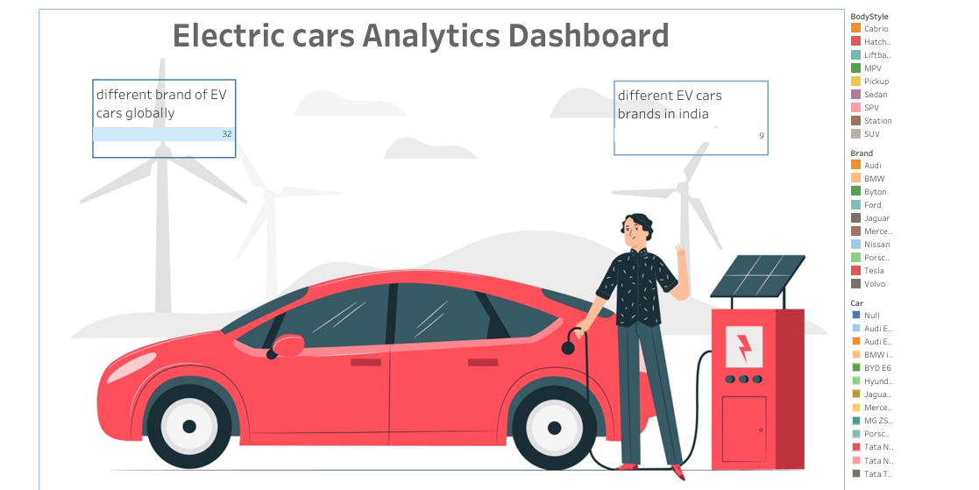

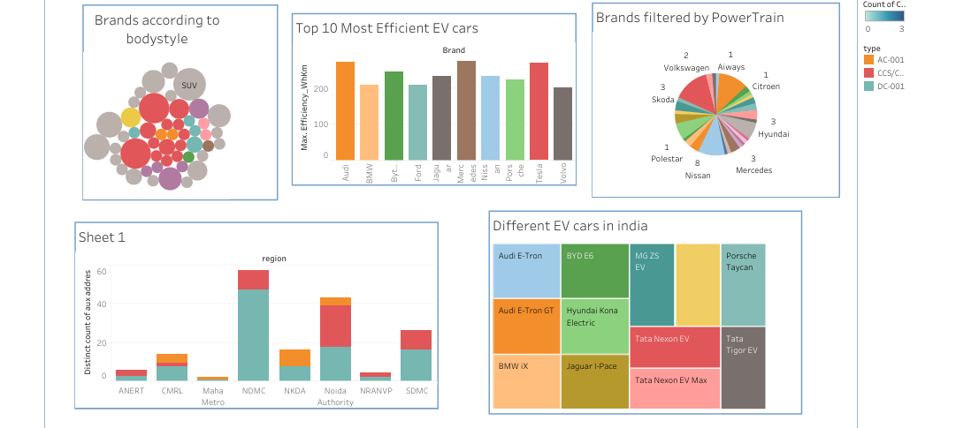

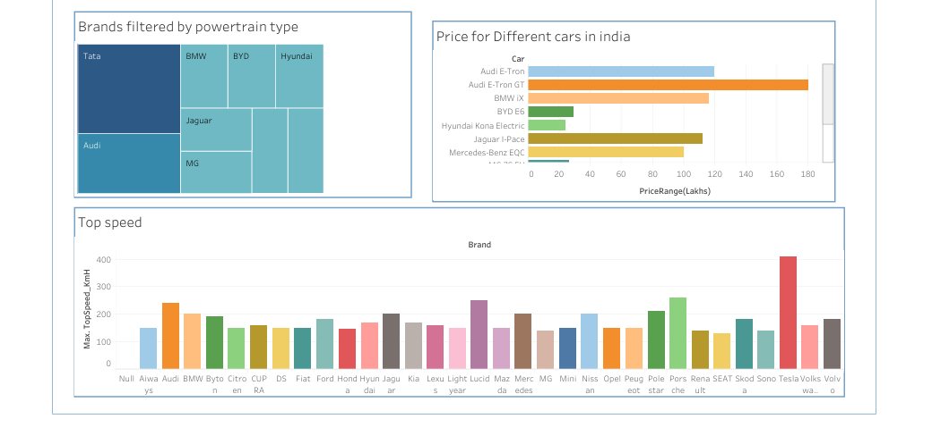

## 6. Story Creation

Built a storyboard in Tableau presenting the data journey from problem to conclusion with text summaries and linked visuals.

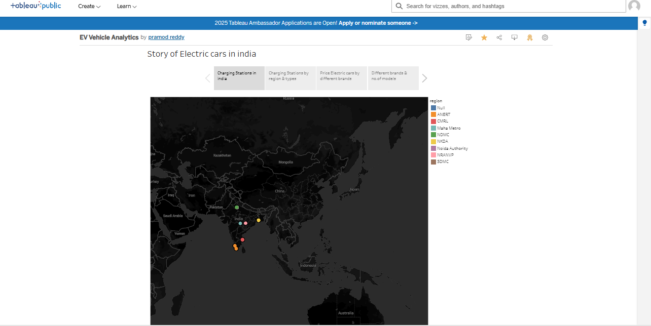

## 7. Publishing to Tableau Public

Published dashboards and stories to Tableau Public and generated shareable embed links.

Dashboard Link:

https://public.tableau.com/shared/ZZY3PXMG4?:display_count=n&:origin=viz_share_link

Story Link: https://public.tableau.com/shared/3DFJRDN2Y?:display_count=n&:origin=viz_share_link

## 8. Web Application Integration

Designed a responsive web interface using HTML, CSS, and Bootstrap. Embedded Tableau content using iframe tags to make the insights accessible online.

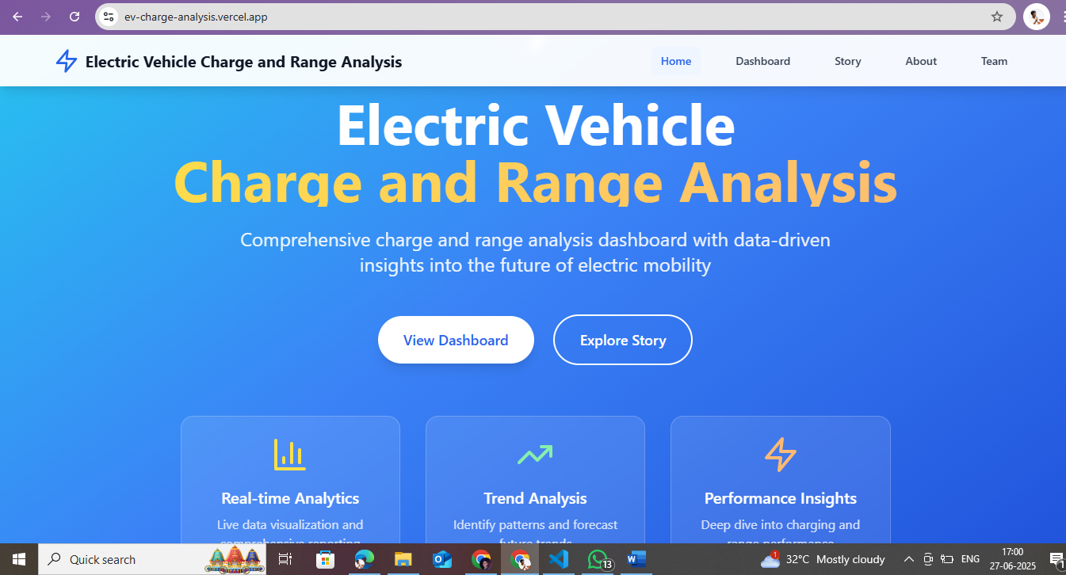

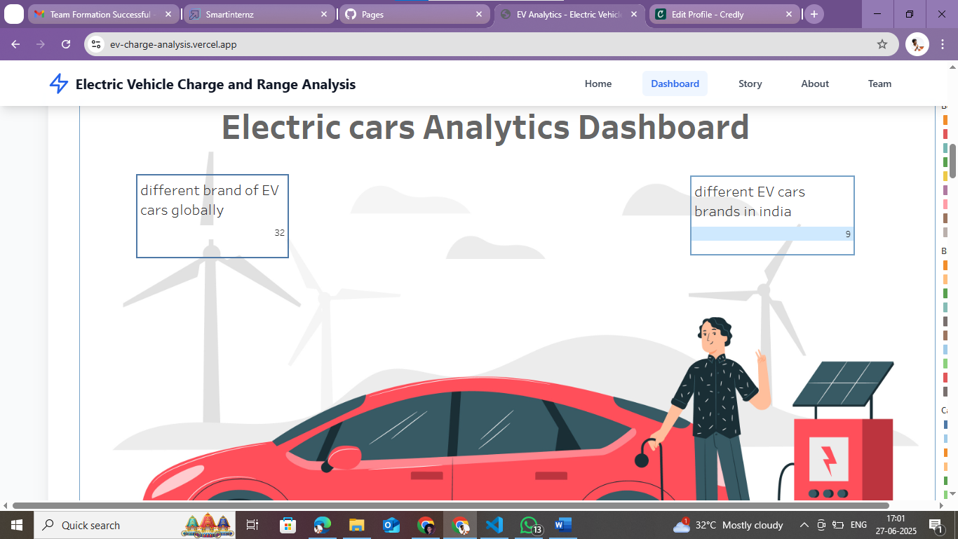

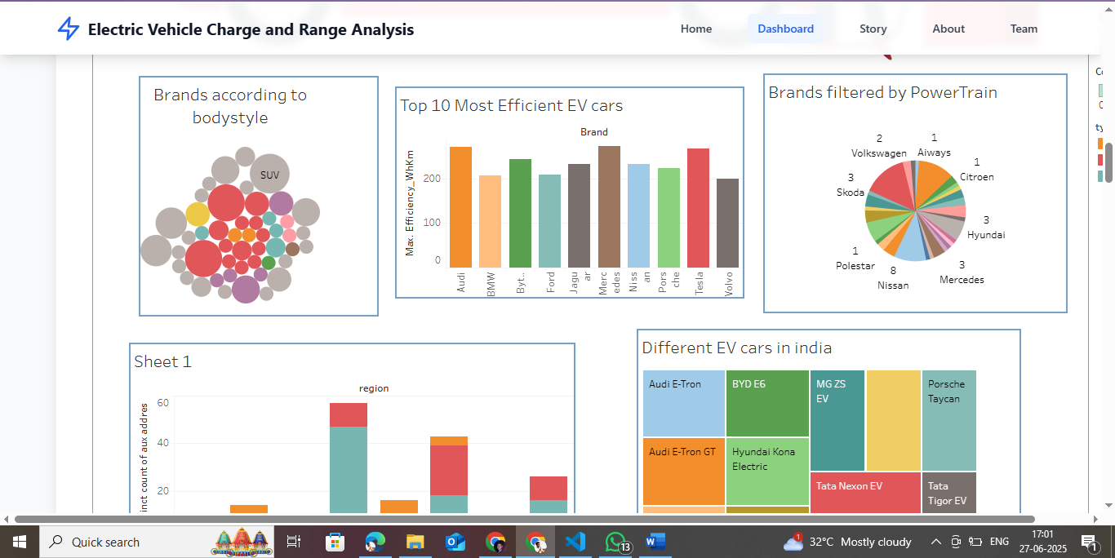

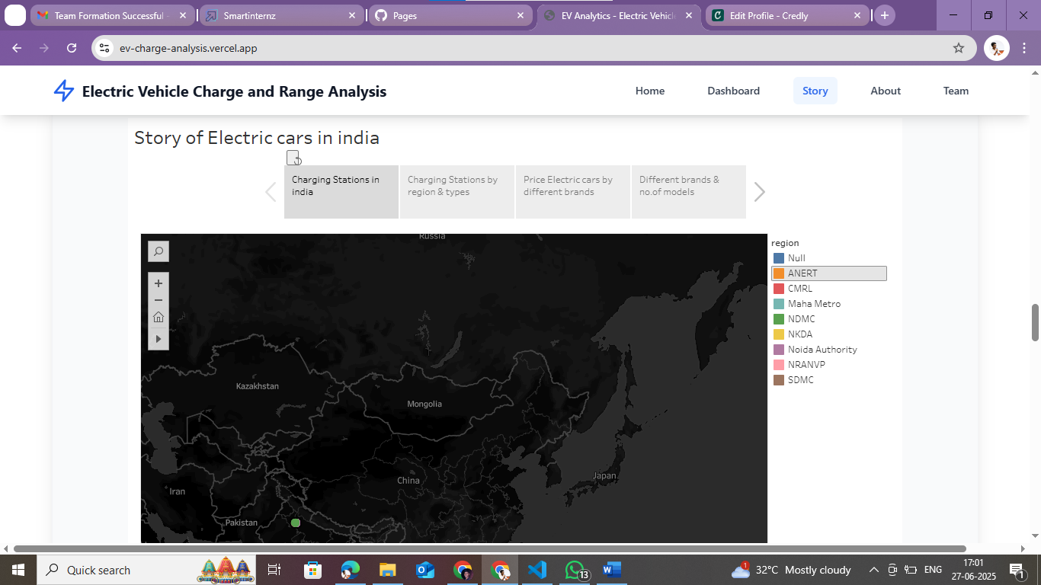

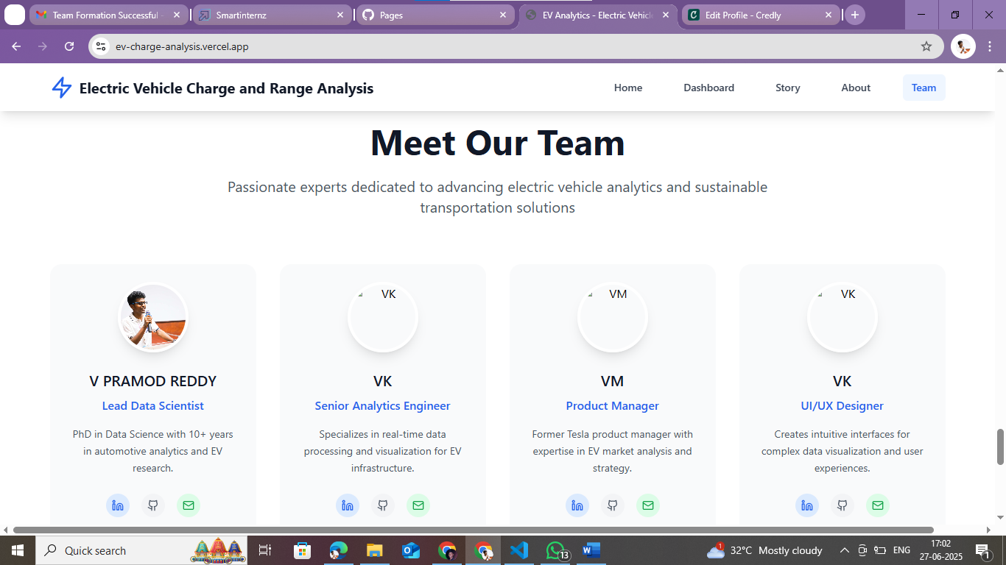

# Insights (To Be Added)

You can insert screenshots of your Tableau visualizations here. Example headings below:

* EV Model Range vs Cost Analysis
* Charging Station Geo Distribution
* EV Sales Trends by Country and Year
* Battery Performance vs Temperature

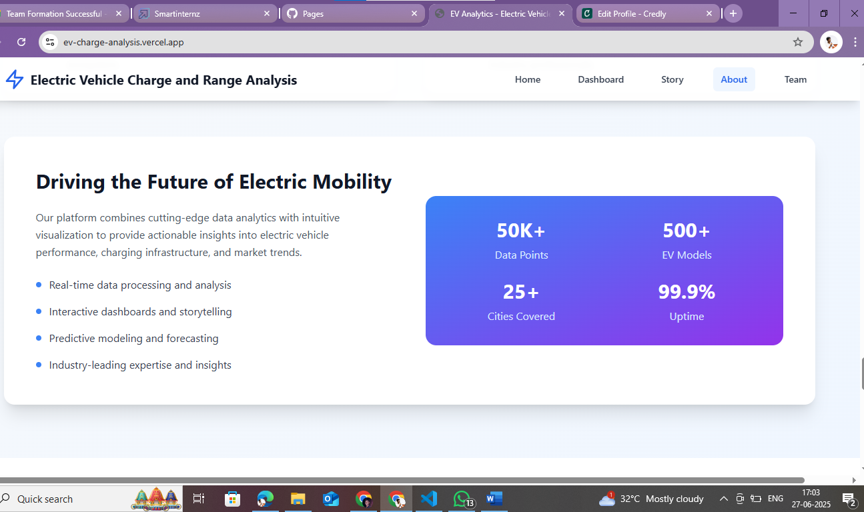

# Outcomes

1. Built a complete visual storytelling tool for EV analytics.
2. Highlighted insights on EV infrastructure and performance across regions.
3. Developed an interactive web portal to host the Tableau visuals.
4. Demonstrated skills in data analytics, dashboarding, and web development.

# Tools Used

1. Data Processing: Excel, Google Sheets

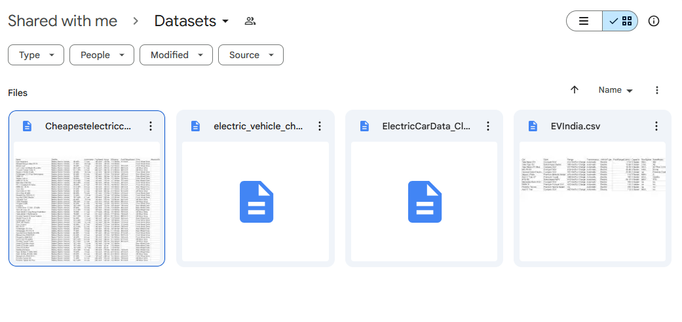  
- Visualization: Tableau Desktop, Tableau Public

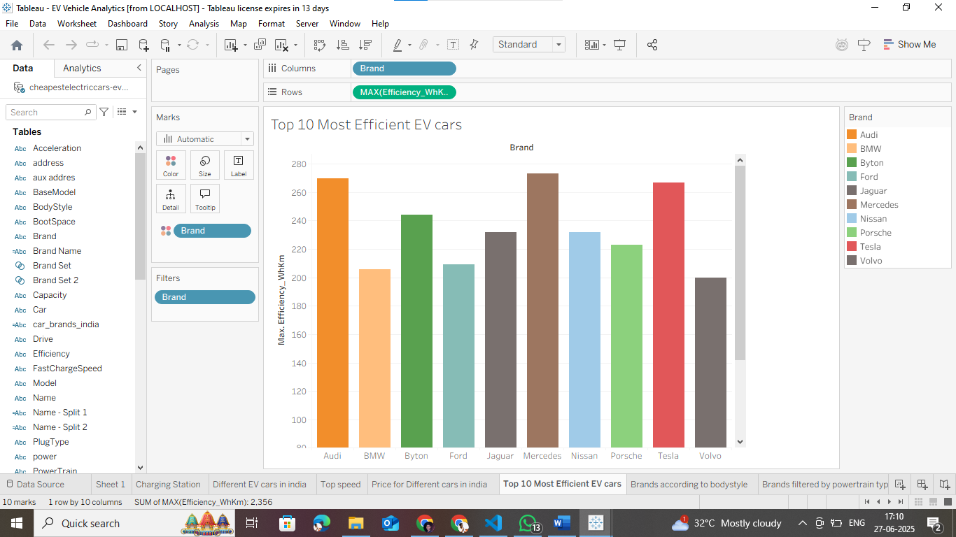

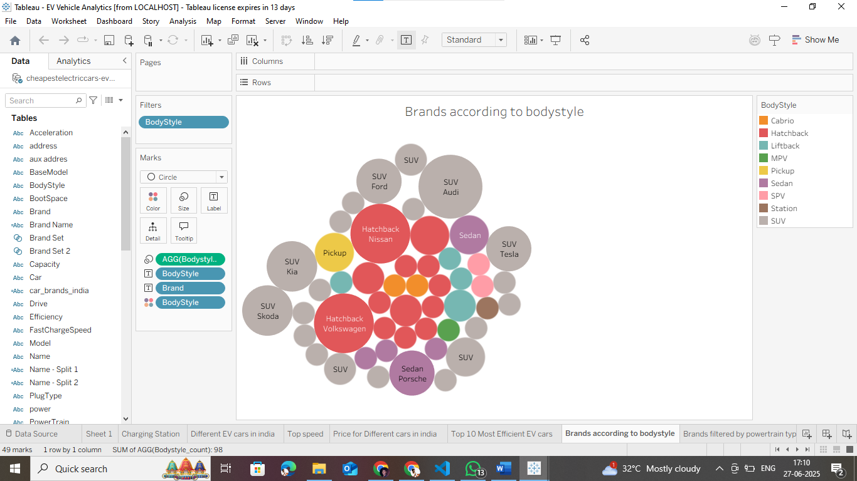  
- Web Development: HTML, CSS, React and tailwan css

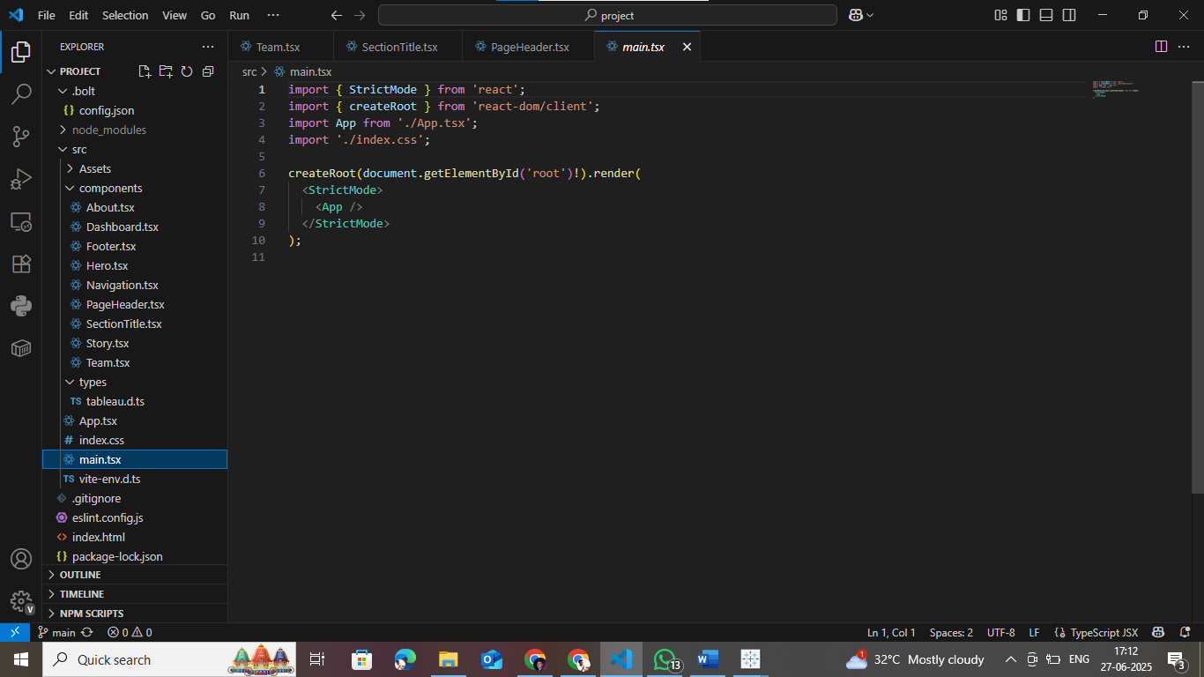  
- Documentation: MS Word / Google Docs

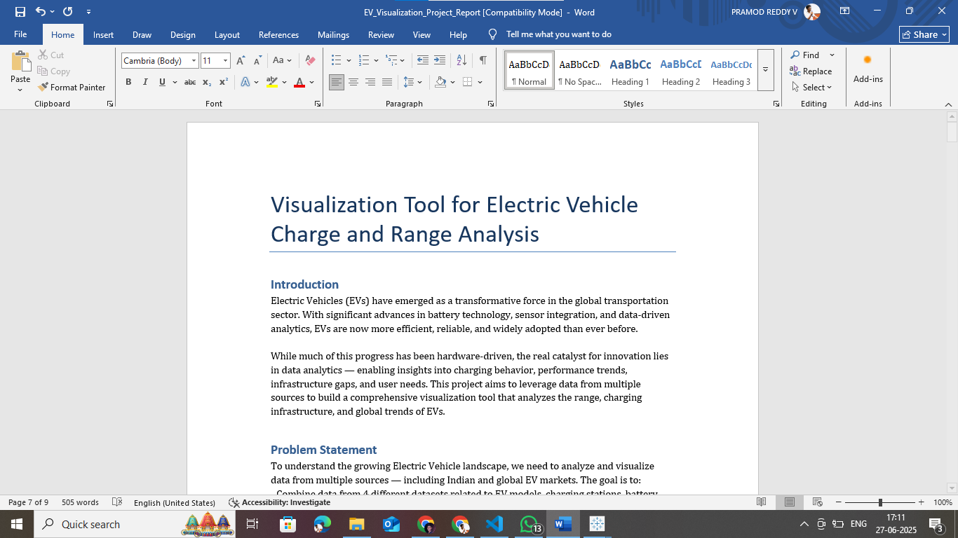

# Source Code

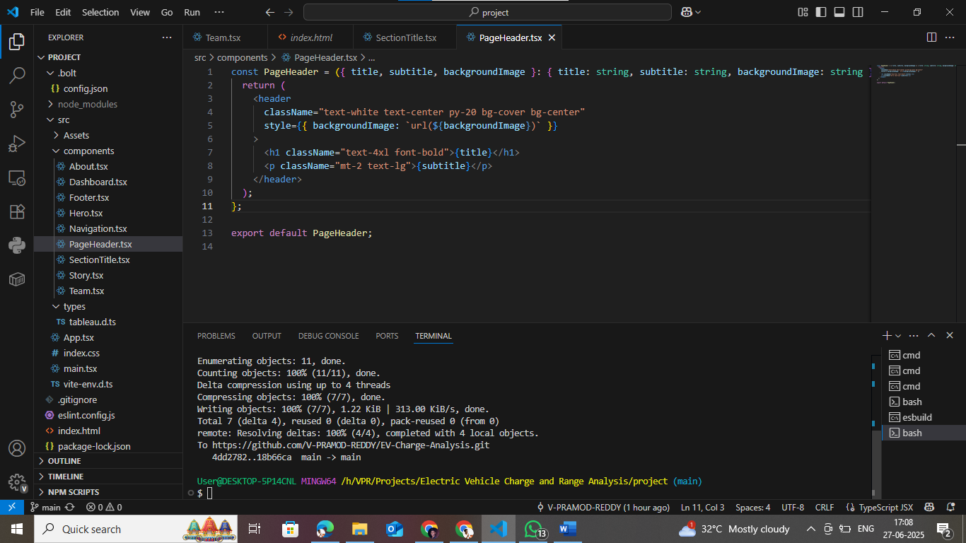

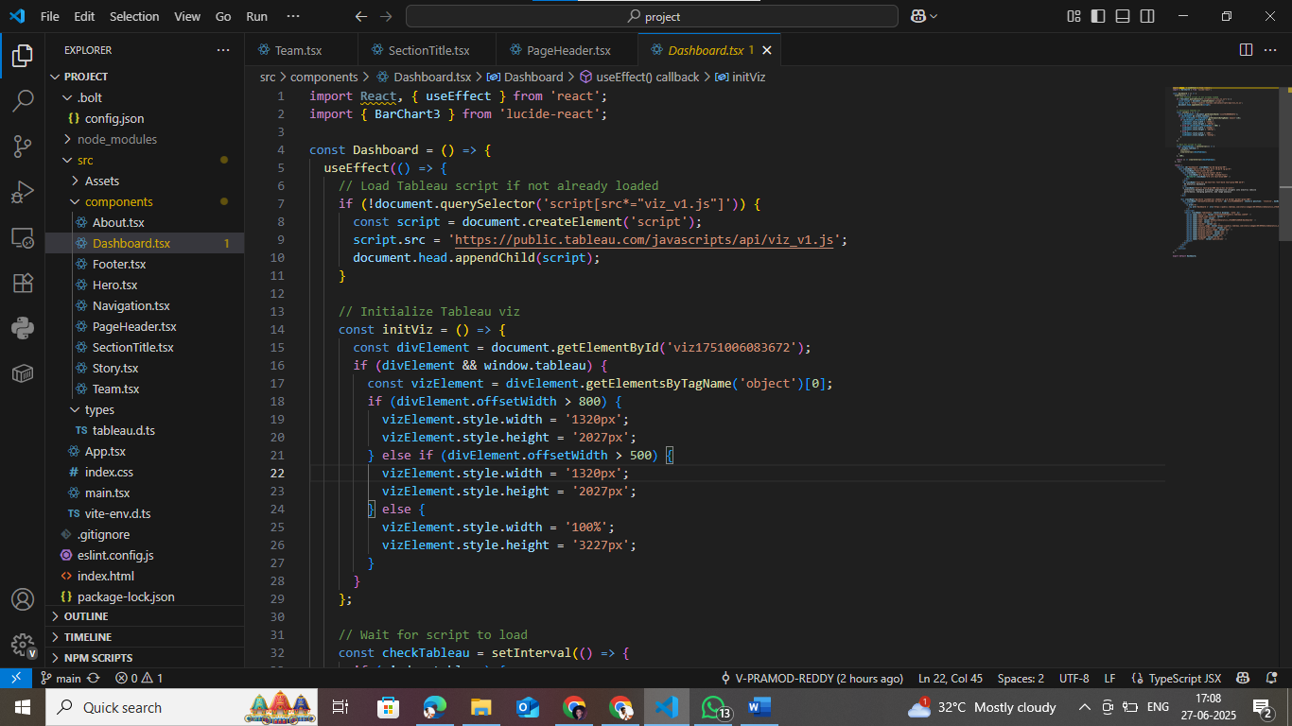

# Developer Information

Name: V Pramod Reddy  
Email: vpramodreddy59@gmail.com  
LinkedIn: <https://www.linkedin.com/in/v-pramod-reddy>

Github: https://github.com/V-PRAMOD-REDDY